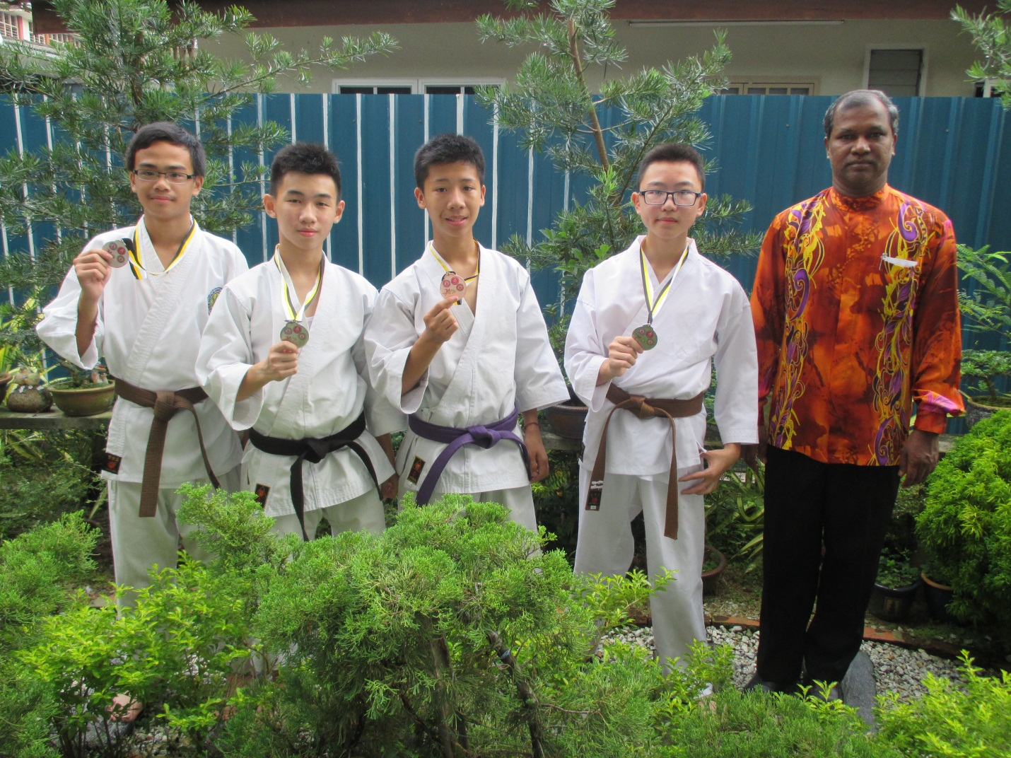

Lee Kah Kit (3T)

– Pingat PERAK Negeri male Individual Kata 14 - 15 years old

Koh Chen Cong (3U)

– Pingat gangsa Negeri male Individual Kata 14 - 15 years old

Alwin Liew Jia Chun (2T), Looi Ze Ying (2U)

– PINGAT PERAK NEGERI MIX TEAM KATA

5th K.O Game Aka Interschool Karate-Do Championship