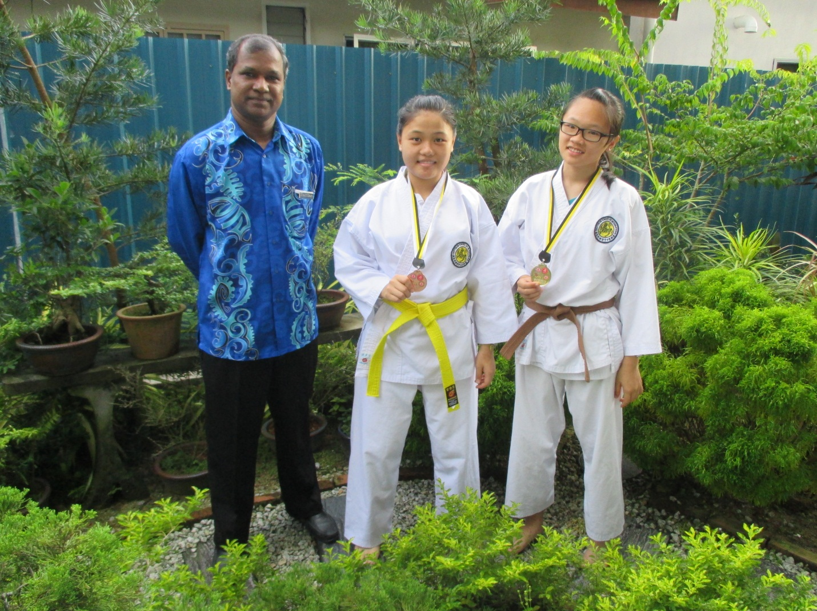

hu mei jiao (5a2)

– Pingat Gangsa Negeri Female Individual Kumite Open

**tan hui min** (3t)

– Pingat Emas Negeri Female Individual Kata 14 - 15 Years Old

5th K.O Game Aka Interschool Karate-Do Championship