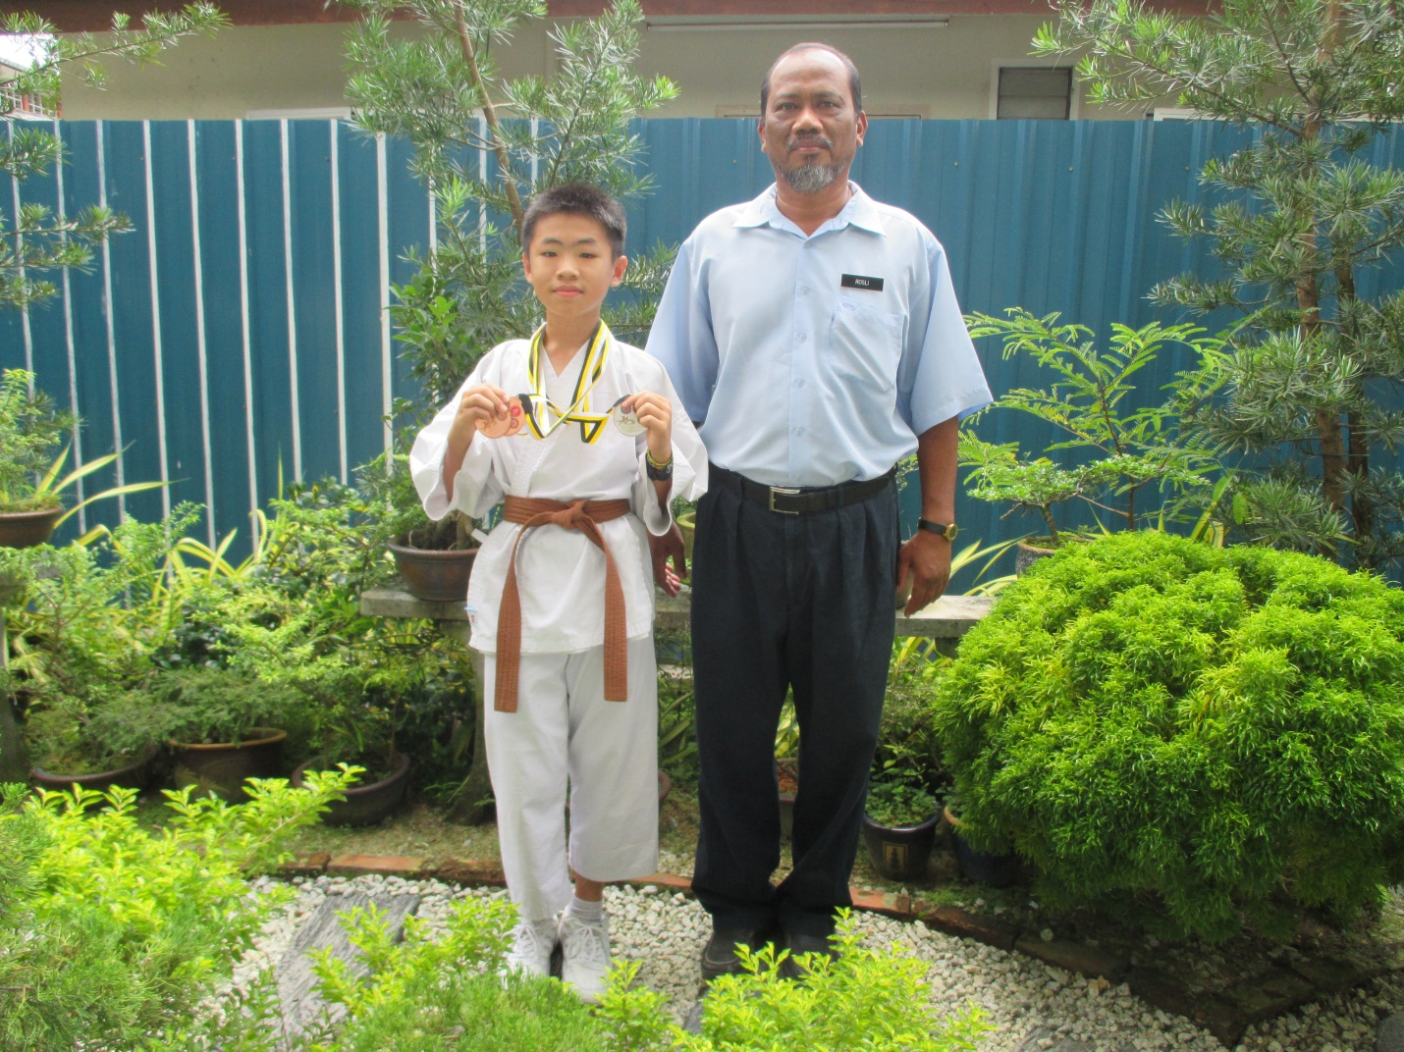

tan tong leong (1j)

5th K.O Game Aka Interschool Karate-Do Championship

– Pingat Gangsa Negeri Male Individual Kata 13 Years Old,

Pingat Gangsa Negeri Male Individual Kumite 13 Years Old, Pingat Perak Negeri Mix Team Kata